Practical-7
PHP Form Processing with Server-Side Validation and CSV/JSON File Storage

Theory
1. Is the form submitted using POST?
Answer: Yes. The form in register.php uses the POST method and submits details to process_registration.php. The PHP processor rejects requests that are not POST.
2. Are inputs validated and sanitized server side?
Answer: Yes. PHP sanitizes submitted fields and validates names, email, mobile number, password, matching confirmation, course, year, gender and acceptance of terms.
3. Is file writing handled safely?
Answer: Yes. The backend writes registration records to CSV and JSON files, using file locking (flock) to help avoid conflicts during concurrent writes.
4. Are success and error responses displayed clearly?
Answer: Yes. The application shows a success response for valid registration and meaningful messages for invalid inputs, security checks or storage failures.
Result:
A PHP-based StudentHub registration form with POST submission, server-side validation, sanitization, CSV/JSON data storage, record viewing and CSRF protection is implemented in the submitted source files.
Evidence of Work (Screenshots)
Screenshots below show the actual StudentHub registration form, submission result, stored CSV/JSON records and records webpage.
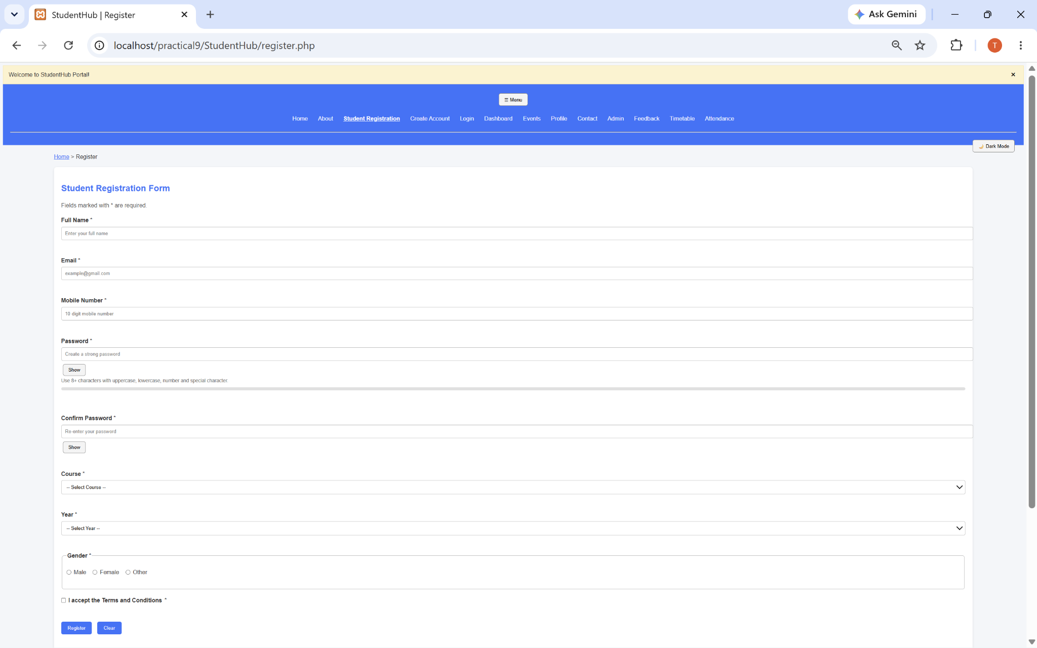
Fig 1: Student Registration Form UI
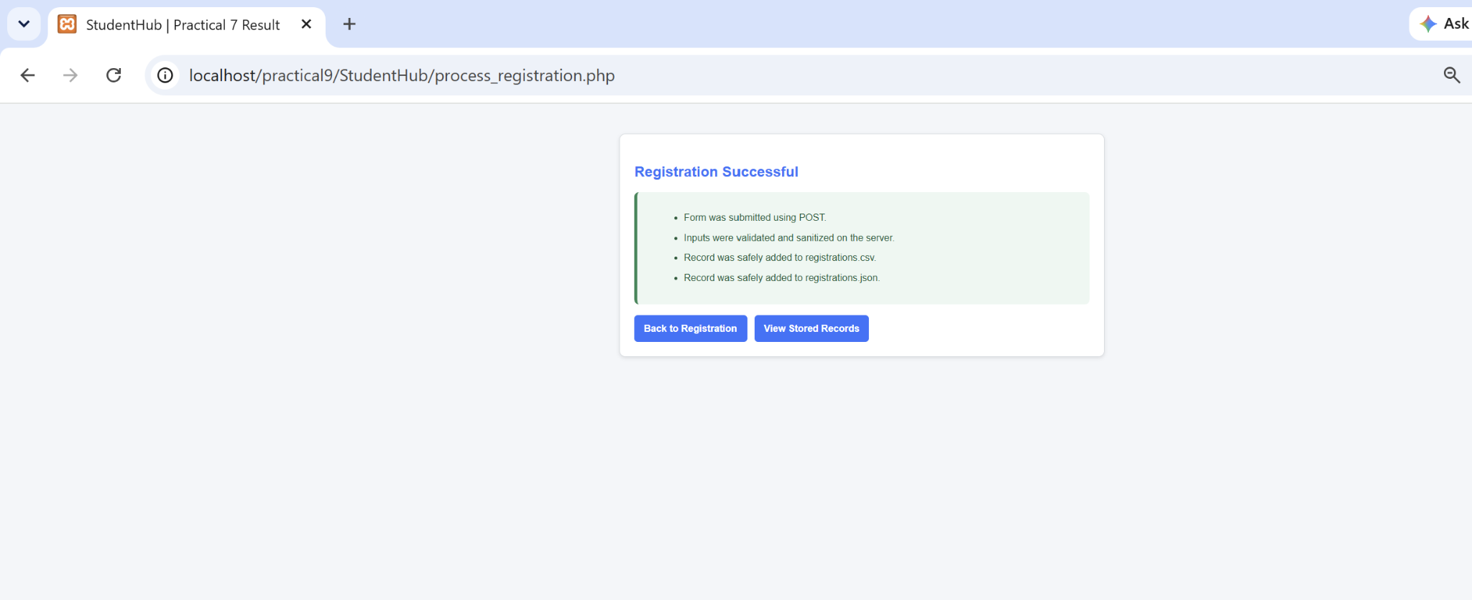
Fig 2: Successful Registration and CSV/JSON Storage

[Insert actual invalid-input validation screenshot here]
Fig 3: Invalid Mobile Number Validation
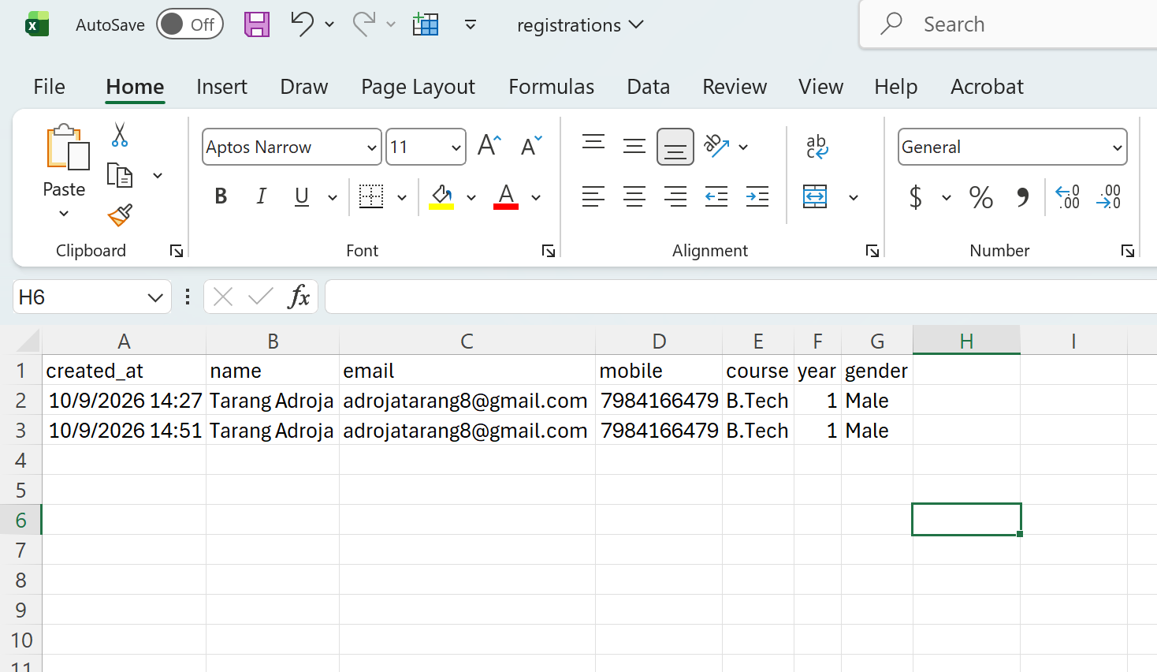
Fig 4: Registration Data Stored in CSV File

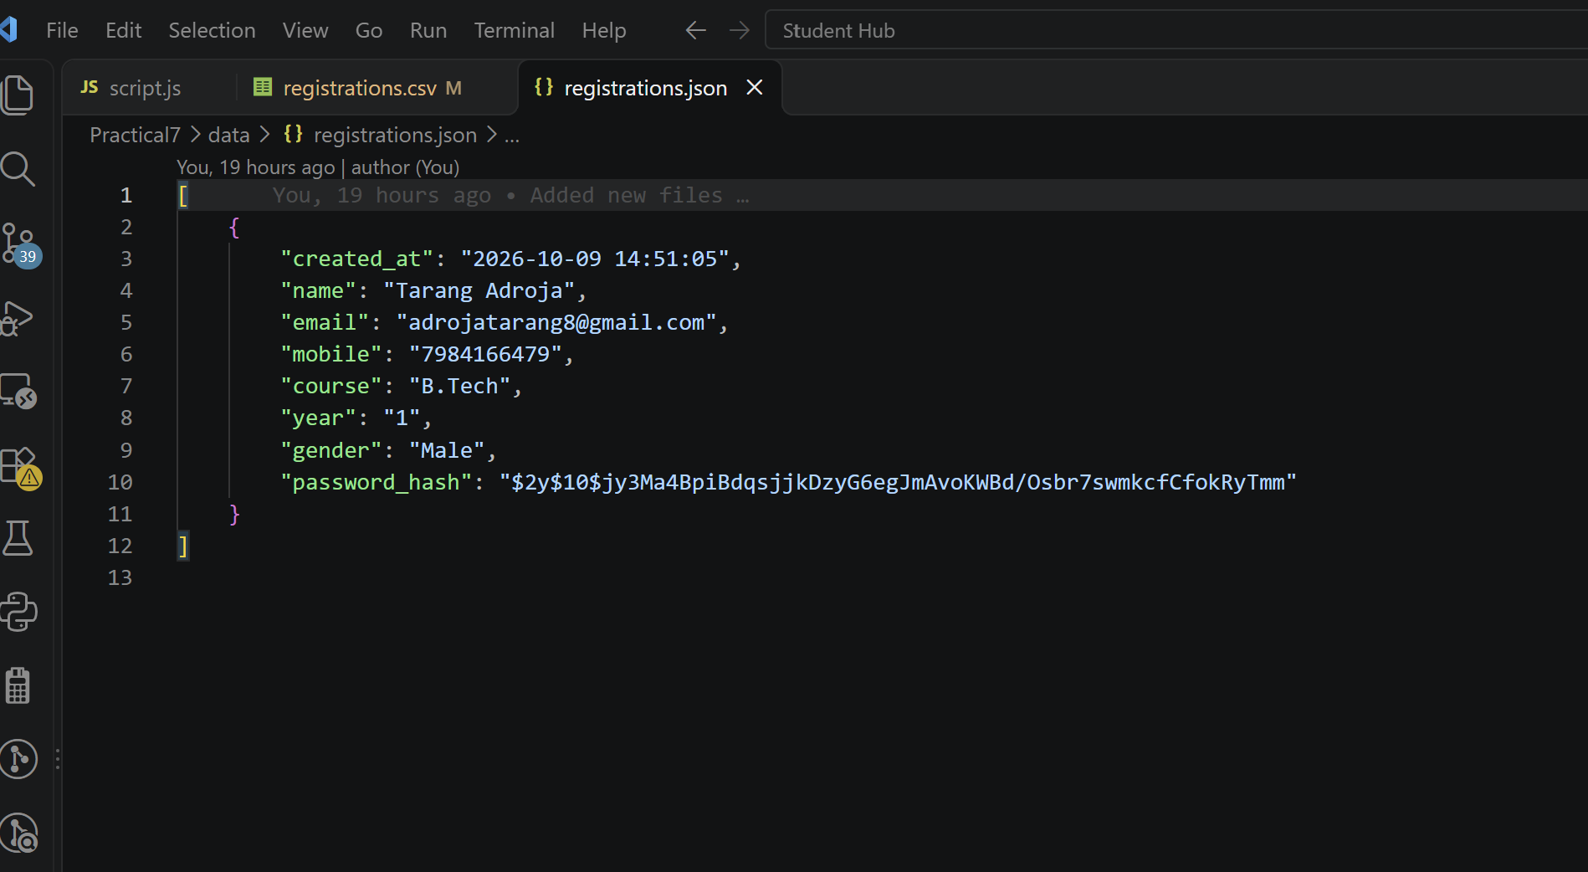
Fig 5: Registration Data Stored in JSON File
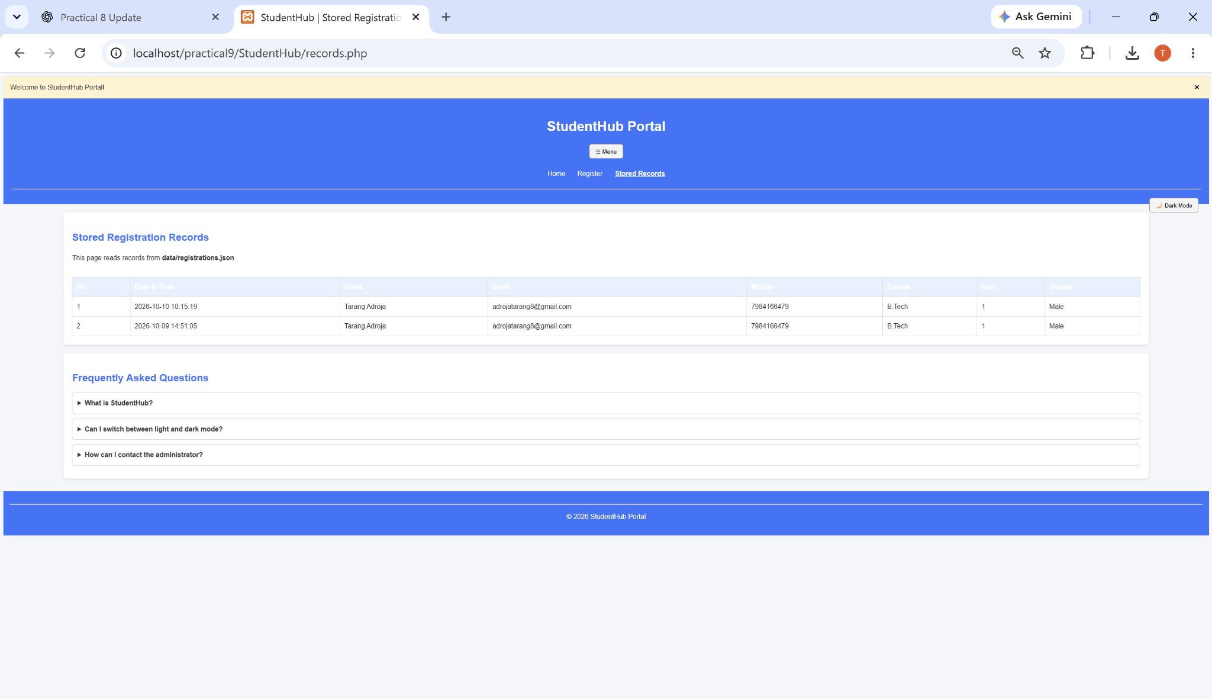
Fig 6: Stored Registration Records Webpage
A. GitHub Repository Link:
https://github.com/adrojatarang8-art/StudentHub

B. Challenges Faced:
• Making the registration form submit data correctly using POST.
• Applying both frontend and PHP backend validation to the same fields.
• Handling invalid form inputs and displaying clear error messages.
• Safely saving and viewing registration records using CSV and JSON.
• Adding security checks such as CSRF token validation.
C. Learning Outcome:-
I learned to process registration forms using PHP and POST, sanitize and validate user inputs, save data in CSV/JSON files, display stored records, and handle security and error messages.

Faculty Remarks:

